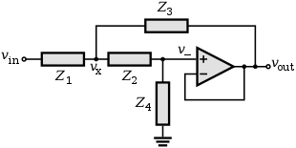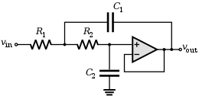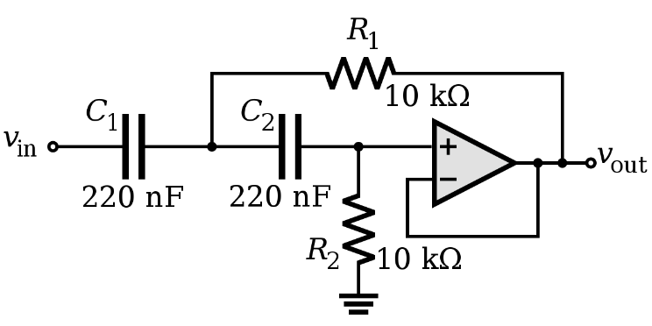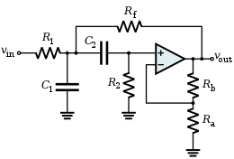

**Sallen-Key filters (Active filters)**

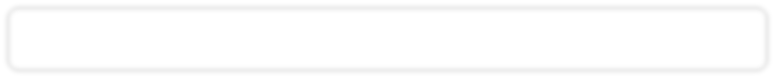

**Name – Tapas Mazumdar ID – 2018A8B40427P**

**Analog Electronics Lab #6 – Study and design of active filters using LM741**

**Objectives**

To study the following active filters using op-amp LM741

1. Low Pass Filter
2. High Pass Filter
3. Band Pass Filter and find out
   1. Plot of voltage gain vs frequency (Bode Plot) for all three different filters,
   2. Calculate 3dB frequency and compare it with simulation in a tabular format.

Also draw the schematic for each filter.

|  |  |
| --- | --- |
| **Sallen-Key topology** | **Sallen-Key Low Pass filter** |
| **Sallen-Key High Pass filter** | **Sallen-Key Band Pass filter** |

**Low Pass Filter**

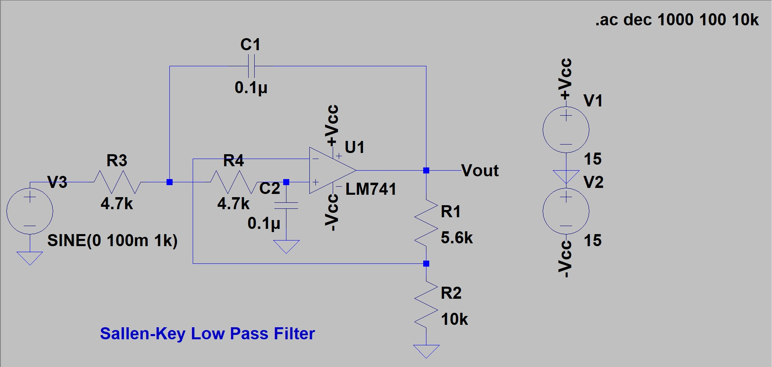

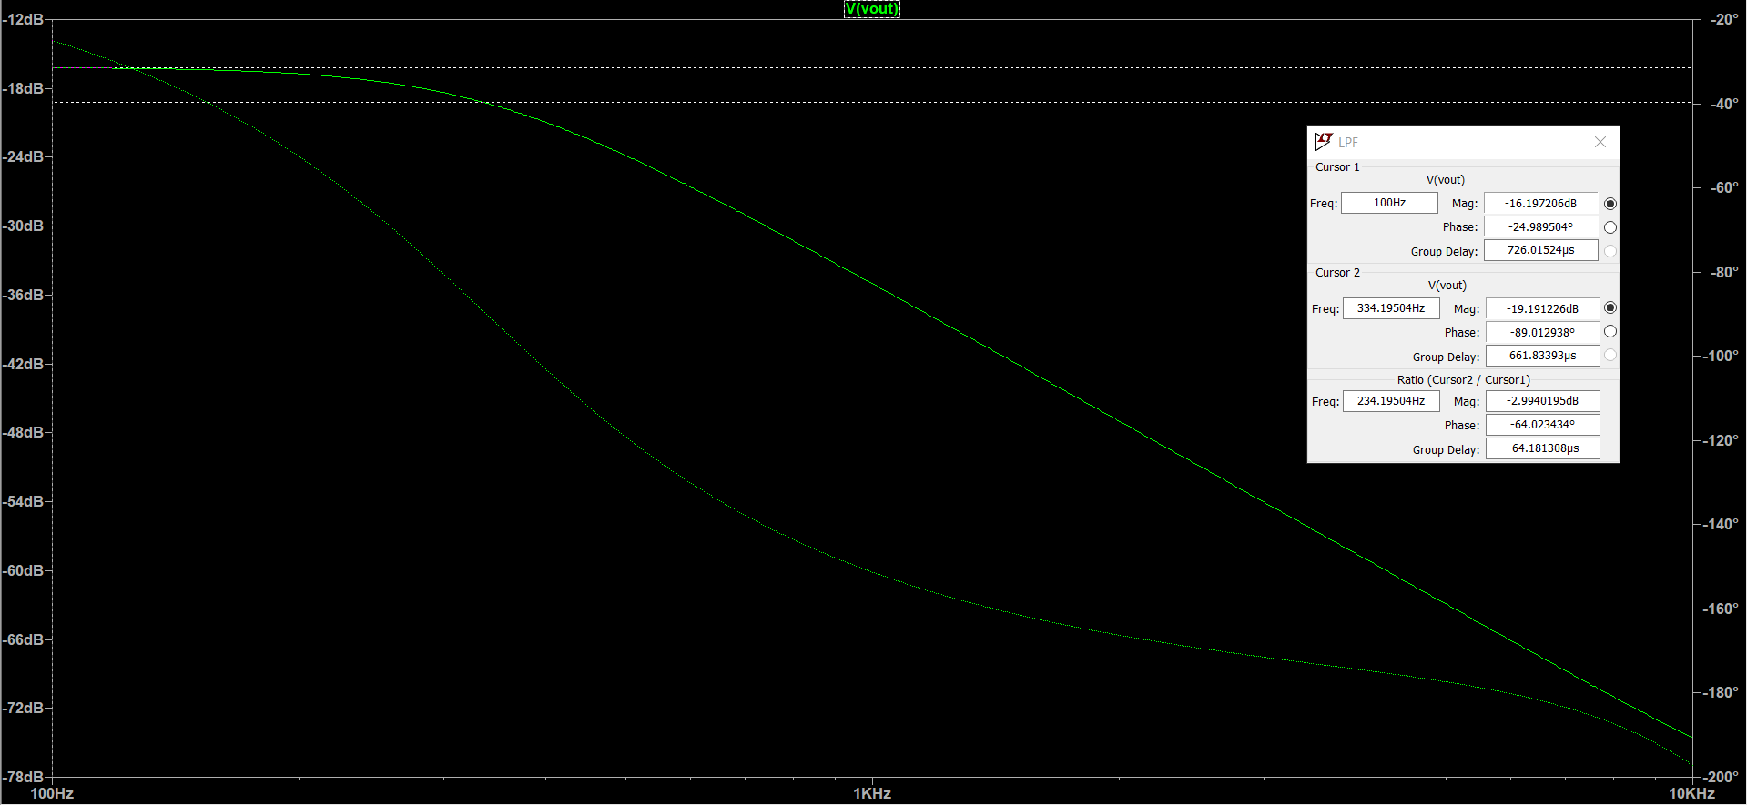

**High Pass Filter**

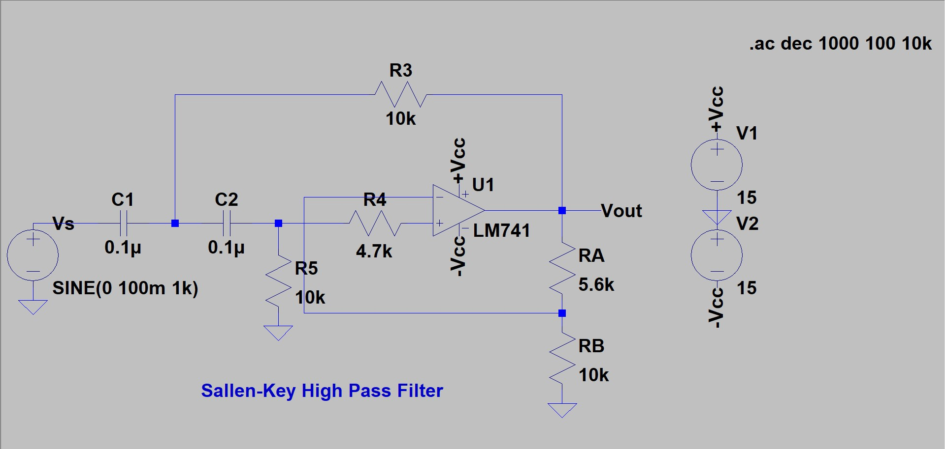

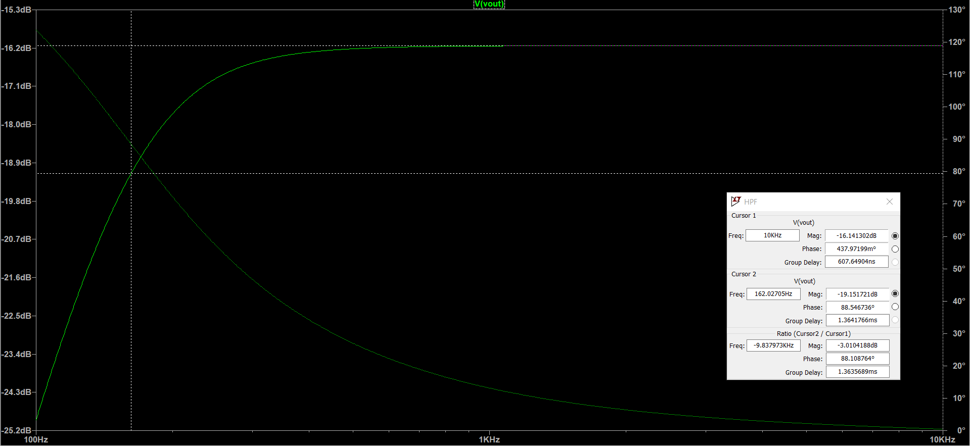

**Band Pass Filter**

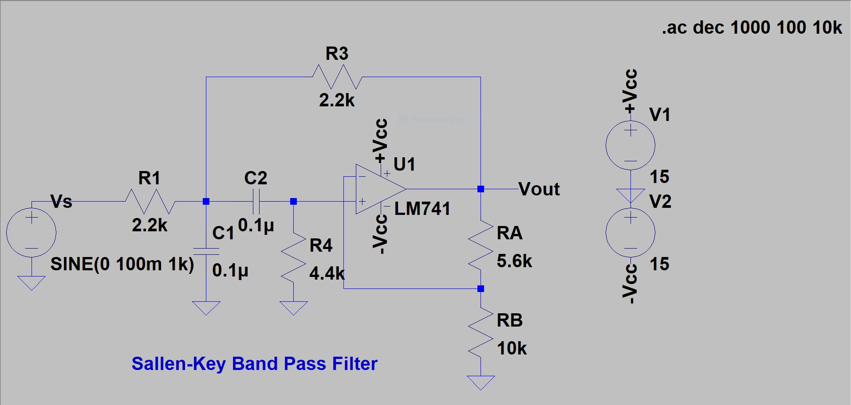

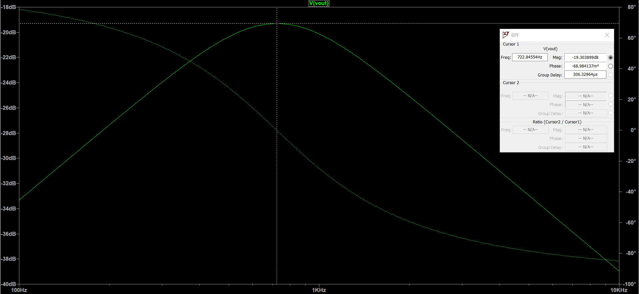

**Results**

**Comparison of simulated and theoretical values of 3dB/cutoff frequencies:**

|  |  |  |
| --- | --- | --- |
| **Type of filter** | **Theoretical value of 3dB/cutoff frequency** | **Simulated value of 3dB/corner frequency** |
| Low pass filter | 1 1  = = 338.627 Hz  2πRC 2π × 4.7k × 0.1u | 334.195 Hz |
| High pass filter | 1 1  = = 159.155 Hz  2πRC 2π × 10k × 0.1u | 162.027 Hz |
| Band pass filter | 1 1  = = 723.432 Hz  2πRC 2π × 2.2k × 0.1u | 722.846 Hz |